**PHP Exercise 11**

**PHP Registration form and validation**

<!DOCTYPE HTML>

<html>

<head>

</head>

<body>

<?php

// define variables and set to empty values

$fnameerr = $mnameerr=$lnameerr=$ageerr=$cityerr=$emailerr =$phoneerr=$eduerr= $gendererr =

 $commenterr = $websiteerr = "";

// define variables and set to empty values

$fname = $mname=$lname=$age=$city=$email =$phone=$edu= $gender = $comment = $website = "";

if ($_SERVER["REQUEST_METHOD"] == "POST") {

  if(empty($_POST["fname"]))

  {

    $fnameerr="First name is required";

  }

  else{

  $fname = test_input($_POST["fname"]);

// check if name only contains letters and whitespace

if (!preg_match("/^[a-zA-Z-' ]*$/",$fname)) {

  $fnameerr = "Only letters and white space allowed";

}

}

  if(empty($_POST["mname"]))

  {

    $mnameerr="Middle name is required";

  }

  else{

  $mname = test_input($_POST["mname"]);

if(!preg_match("/^[a-zA-Z-']*$/",$mname)){

  $mnameerr="Only letter and white spaces are required";

}

}

  if(empty($_POST["lname"]))

  {

    $lnameerr="last name is required";

  }

  else{

  $lname = test_input($_POST["lname"]);

  if(!preg_match("/^[a-zA-Z-']*$/",$lname)){

    $lnameerr="Only letter and white spaces are required";

  }

}

  if(empty($_POST["age"]))

  {

    $ageerr="Your age is required";

  }

  else{

  $age = test_input($_POST["age"]);}

  if(empty($_POST["city"]))

  {

    $cityerr="city name is required";

  }

  else{

  $city = test_input($_POST["city"]);}

  if(empty($_POST["email"]))

  {

    $emailerr="Email is required";

  }

  else{

  $email = test_input($_POST["email"]);

// check if e-mail address is well-formed

if (!filter_var($email,FILTER_VALIDATE_EMAIL)) {

  $emailerr = "Invalid email format";

}

}

  if(empty($_POST["phone"]))

  {

    $phoneerr="Phone number is required";

  }

  else{

  $phone = test_input($_POST["phone"]);}

  if(empty($_POST["edu"]))

  {

    $eduerr="Eduacation field is required";

  }

  else{

  $edu = test_input($_POST["edu"]);}

  if(empty($_POST["website"]))

  {

    $websiteerr="website is required";

  }

  else{

  $website = test_input($_POST["website"]);

 // check if URL address syntax is valid (this regular expression also allows dashes in the URL)

 if (!preg_match("/\b(?:(?:https?|ftp):\/\/|www\.)[-a-z0-9+&@#\/%?=~_|!:,.;

 ]*[-a-z0-9+&@#\/%=~_|]/i",$website)) {

  $websiteerr = "Invalid URL";

}

}

  if(empty($_POST["comment"]))

  {

    $commenterr="comment are optional ";

  }

  else{

  $comment = test_input($_POST["comment"]);}

  if(empty($_POST["gender"]))

  {

    $gendererr="select gender is  required";

  }

  else{

  $gender = test_input($_POST["gender"]);}

}

function test_input($data) {

  $data = trim($data);

  $data = stripslashes($data);

  $data = htmlspecialchars($data);

  return $data;

}

?>

<h2><mark>Registraion for Employees by ASE Ajman khan</mark></h2>

<form method="post" action="<?php echo htmlspecialchars($_SERVER["PHP_SELF"]);?>">

<div>

fname:<input type="text" name="fname" value="<?php echo $fname; ?>"  placeholder="Enter first name" >

<span class="error">* <?php echo $fnameerr;?></span>

<br><br>

mname:<input type="text" name="mname" value="<?php echo $mname; ?>"  placeholder="Enter middle name"  >

<span class="error">* <?php echo $mnameerr;?></span>

<br><br>

lname:<input type="text" name="lname" value="<?php echo $lname; ?>" placeholder="Enter last name"  >

<span class="error">* <?php echo $lnameerr;?></span>

<br><br>

</div>

<div>

age:<input type="number" name="age" value="<?php echo $age; ?>"   placeholder="Enter your age"  >

<span class="error">* <?php echo $ageerr;?></span>

<br><br>

</div>

<div>

city:<input type="text" name="city" value="<?php echo $city; ?>" placeholder="Enter your city" >

<span class="error">* <?php echo $cityerr;?></span>

<br><br>

</div>

<div>

email:<input type="email" name="email" value="<?php echo $email; ?>"  placeholder="Enter your email"  >

<span class="error">* <?php echo $emailerr;?></span>

<br><br>

</div>

<div>

phone:<input type="text" name="phone" value="<?php echo $phone; ?>"  placeholder="Enter your phone" >

<span class="error">* <?php echo $phoneerr;?></span>

<br><br>

</div>

<div>

edu:<input type="text" name="edu" value="<?php echo $edu; ?>"   placeholder="Enter your edu"  >

<span class="error">* <?php echo $eduerr;?></span>

<br><br>

</div>

<div>

  Website: <input type="text" name="website" value="<?php echo $website; ?>" >

  <mark><span class="error">* <?php echo $websiteerr;?></span></mark>

  <br><br>

  </div>

  <div>

  Comment:<br>

  <textarea name="comment" rows="5" cols="40" <?php echo $comment; ?>></textarea>

  <span class="error">* <?php echo $commenterr;?></span>

  <br><br>

  </div>

  <div>

  Gender:

  <input type="radio" name="gender" <?php if(isset($gender)&& $gender=="female") echo "Checked"; ?>value="female" >Female

  <input type="radio" name="gender" <?php if(isset($gender)&& $gender=="male") echo "Checked"; ?> value="male">Male

  <input type="radio" name="gender" <?php if(isset($gender)&& $gender=="other") echo "Checked"; ?> value="other">Other

  <mark><span class="error">* <?php echo $gendererr;?></span></mark>

  <br><br>

  </div>

  <input type="submit" name="submit" value="Submit">

</form>

<?php

if(isset($_POST['fname'],$_POST['mname'],$_POST['lname'],$_POST['age'],$_POST['city'],

$_POST['email'],$_POST['phone'],$_POST['edu'],$_POST['website'],$_POST['comment'],$_POST['gender'])){

echo "<h2><mark>Your Data </mark>:</h2>";

echo "Your first name is  $fname";

echo "<br>";

echo "<mark>Your Middle name is  $mname </mark>";

echo "<br>";

echo "Your last  name is  $lname ";

echo "<br>";

echo "<mark >Your full name is  $fname $mname $lname </mark>";

echo "<br>";

echo "Your age is  $age";

echo "<br>";

echo " Your city name is $city ";

echo "<br>";

echo "Your Email is   $email ";

echo "<br>";

echo "Your Phone number  is  $phone ";

echo "<br>";

echo "Your Education  is  $edu ";

echo "<br>";

echo "Your Website is  $website  ";

echo "<br>";

echo "Your comments  are  $comment  ";

echo "<br>";

echo "Specified gender is  $gender ";

}

?>

</body>

</html>

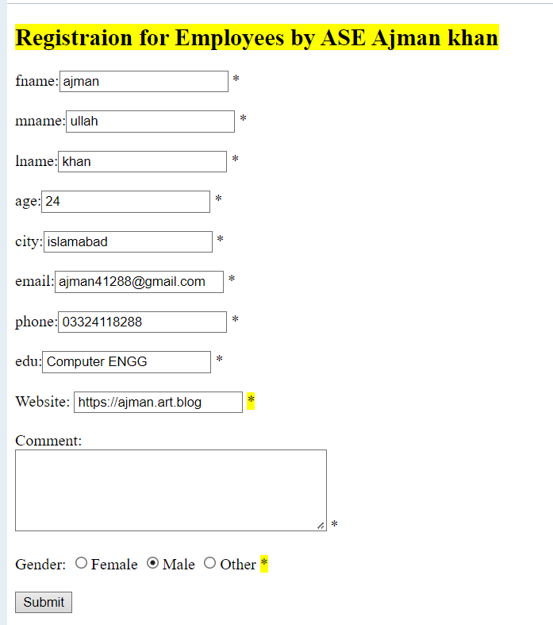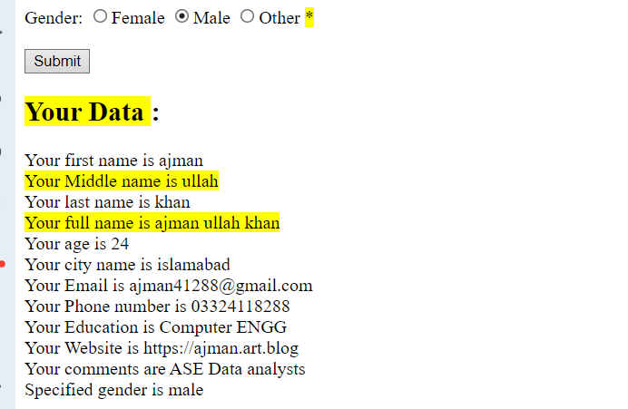

## Registraion for Employees by ASE Ajman khan

窗体顶端

fname: *  
  
mname: *  
  
lname: *

age: *

city: *

email: *

phone: *

edu: *

Website:  *

Comment:  
 *

Gender: Female Male Other *



窗体底端

## Your Data :

Your first name is ajman  
Your Middle name is ullah  
Your last name is khan  
Your full name is ajman ullah khan  
Your age is 24  
Your city name is islamabad  
Your Email is ajman41288@gmail.com  
Your Phone number is 03324118288  
Your Education is Computer ENGG  
Your Website is https://ajman.art.blog  
Your comments are ASE Data analysts  
Specified gender is male

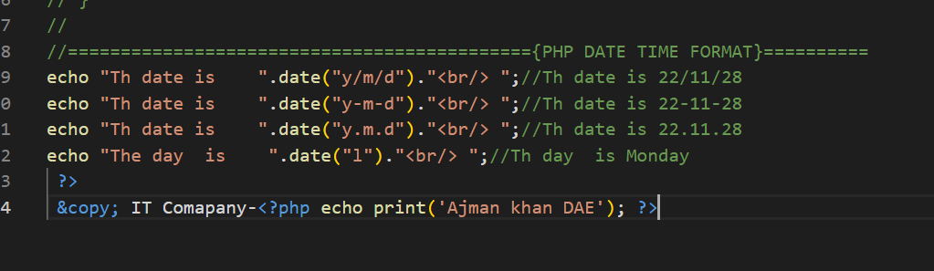

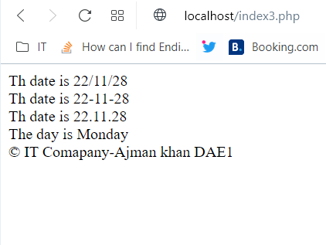

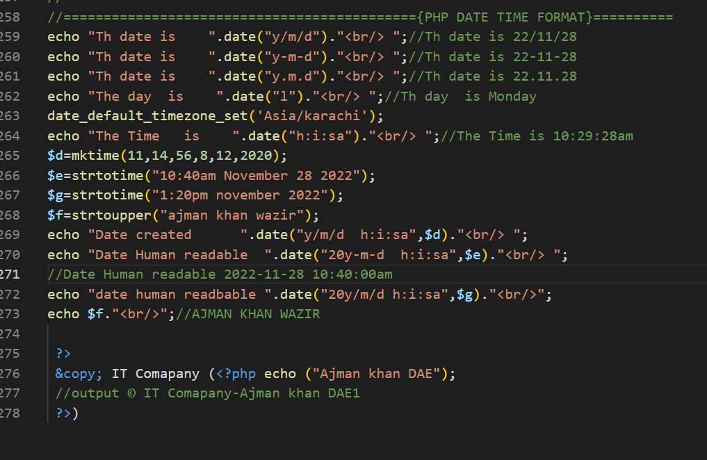

//============================================{PHP DATE TIME FORMAT}==========

echo "Th date is    ".date("y/m/d")."<br/> ";//Th date is 22/11/28

echo "Th date is    ".date("y-m-d")."<br/> ";//Th date is 22-11-28

echo "Th date is    ".date("y.m.d")."<br/> ";//Th date is 22.11.28

echo "The day  is    ".date("l")."<br/> ";//Th day  is Monday

date_default_timezone_set('Asia/karachi');

echo "The Time   is    ".date("h:i:sa")."<br/> ";//The Time is 10:29:28am

$d=mktime(11,14,56,8,12,2020);

$e=strtotime("10:40am November 28 2022");

$g=strtotime("1:20pm november 2022");

$f=strtoupper("ajman khan wazir");

echo "Date created      ".date("y/m/d  h:i:sa",$d)."<br/> ";

echo "Date Human readable  ".date("20y-m-d  h:i:sa",$e)."<br/> ";

//Date Human readable 2022-11-28 10:40:00am

echo "date human readbable ".date("20y/m/d h:i:sa",$g)."<br/>";

echo $f."<br/>";//AJMAN KHAN WAZIR

 ?>

 &copy; IT Comapany (<?php echo ("Ajman khan DAE");

 //output © IT (Comapany-Ajman khan DAE)

 ?>)

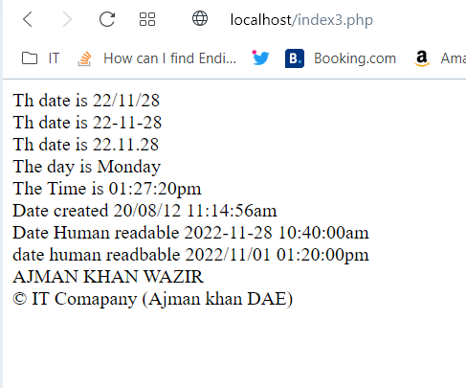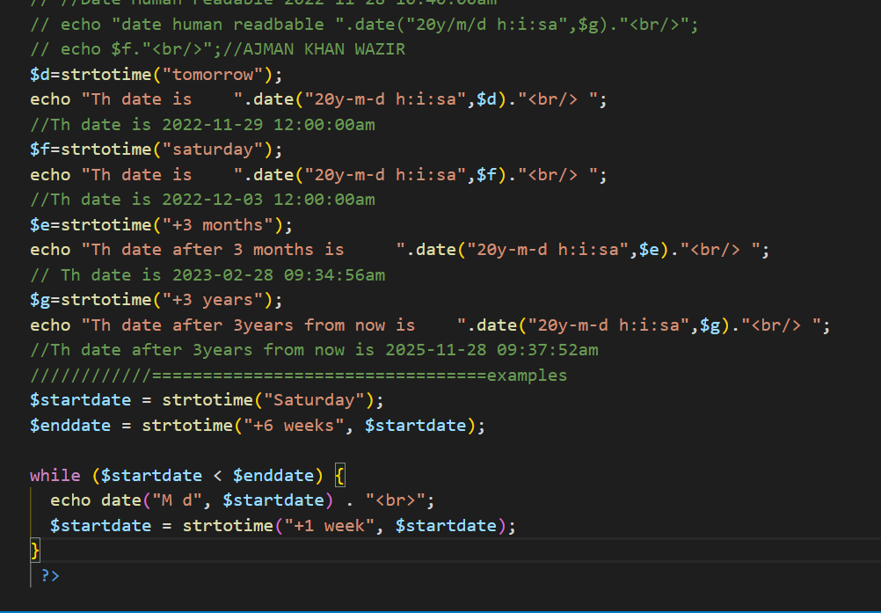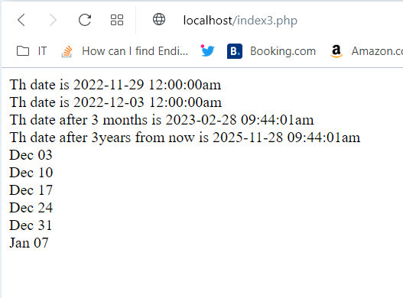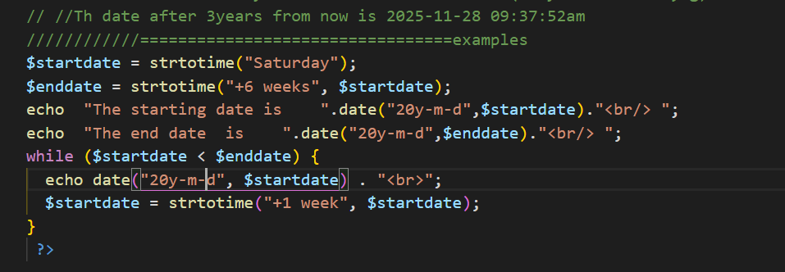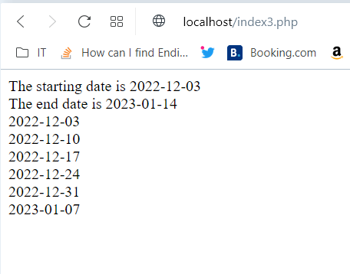

////////////=================================examples

$startdate = strtotime("Saturday");

$enddate = strtotime("+6 weeks", $startdate);

echo  "The starting date is    ".date("20y-m-d",$startdate)."<br/> ";

echo  "The end date  is    ".date("20y-m-d",$enddate)."<br/> ";

while ($startdate < $enddate) {

  echo date("20y-m-d", $startdate) . "<br>";

  $startdate = strtotime("+1 week", $startdate);

}

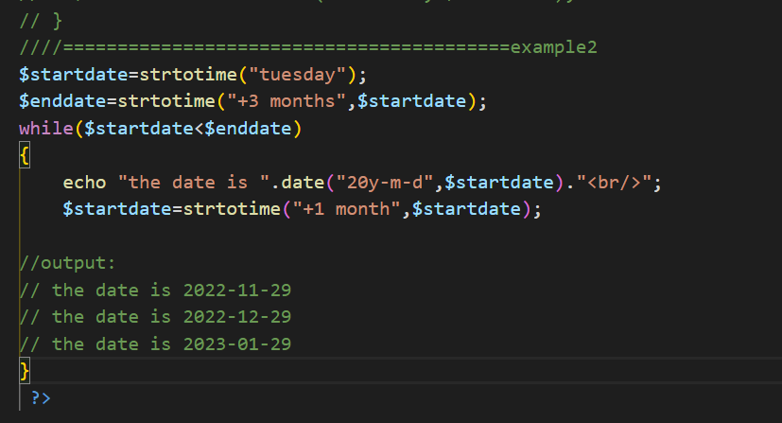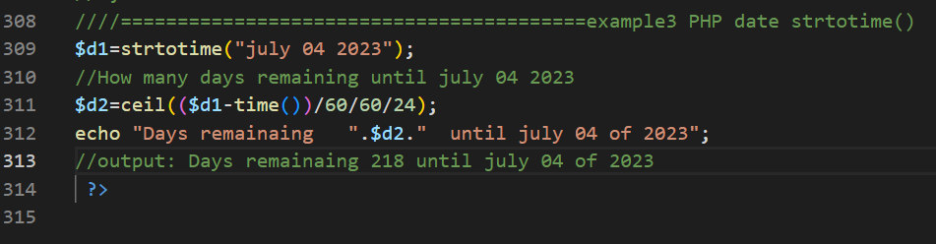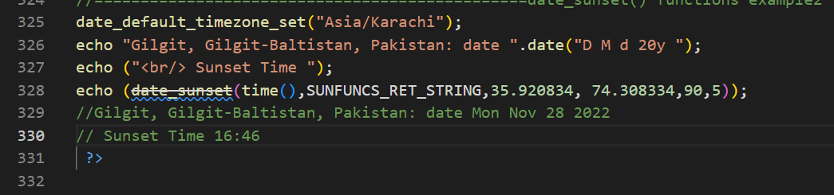

//===============================================date_sunset() functions example2

date_default_timezone_set("Asia/Karachi");

echo "Gilgit, Gilgit-Baltistan, Pakistan: date ".date("D M d 20y ");

echo ("<br/> Sunset Time ");

echo (date_sunset(time(),SUNFUNCS_RET_STRING,35.920834, 74.308334,90,5));

//Gilgit, Gilgit-Baltistan, Pakistan: date Mon Nov 28 2022

// Sunset Time 16:46

 ?>

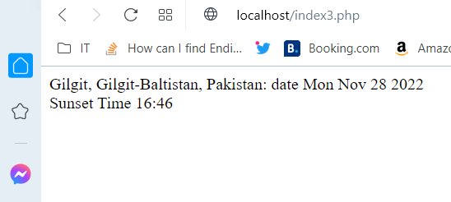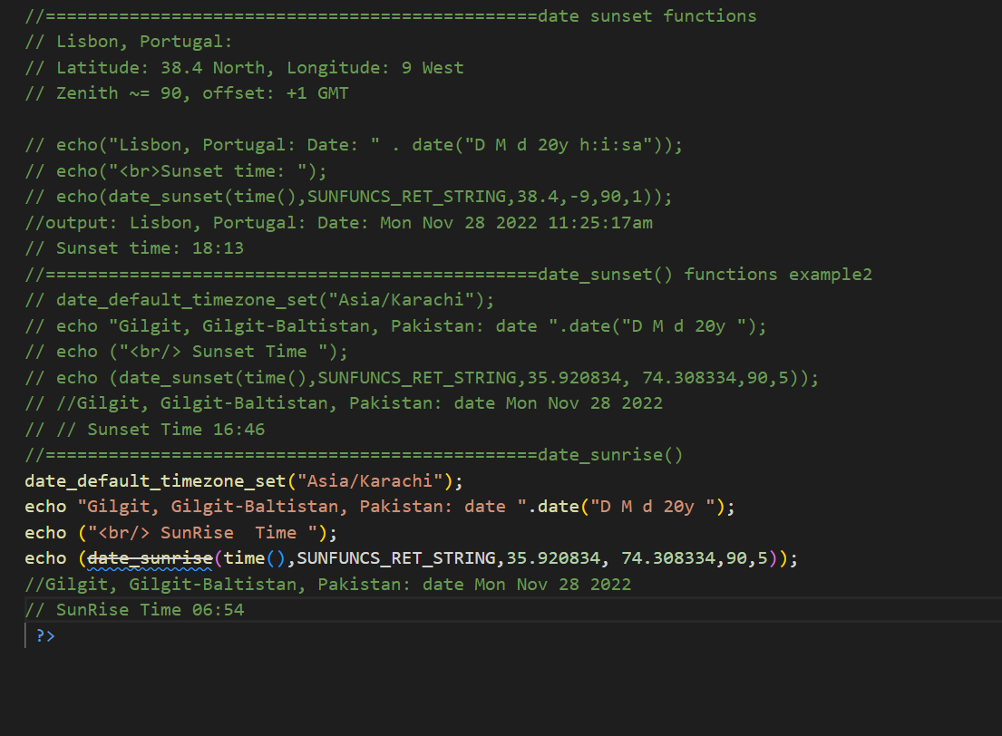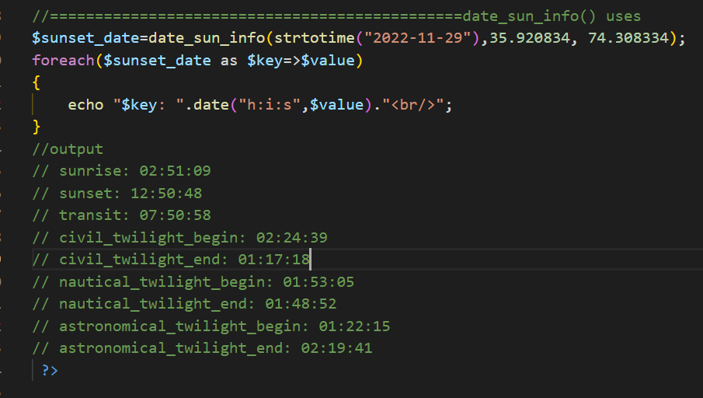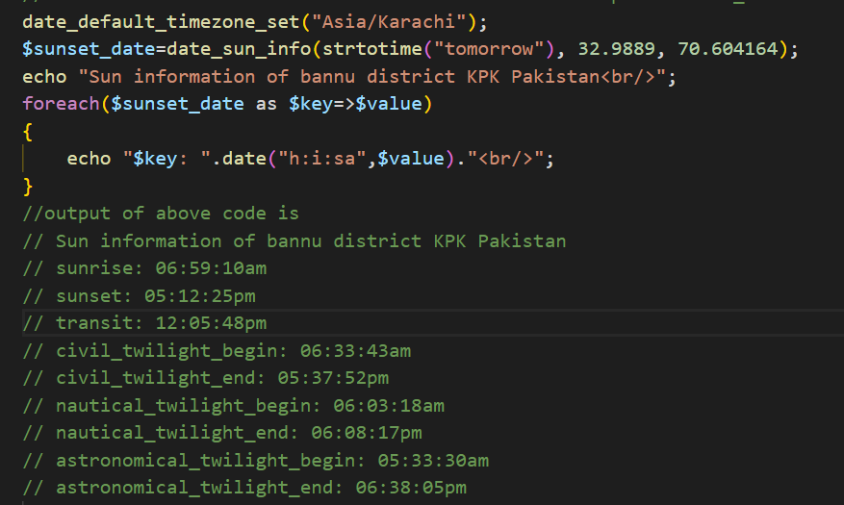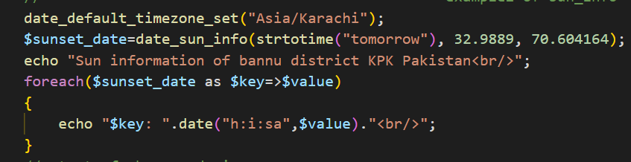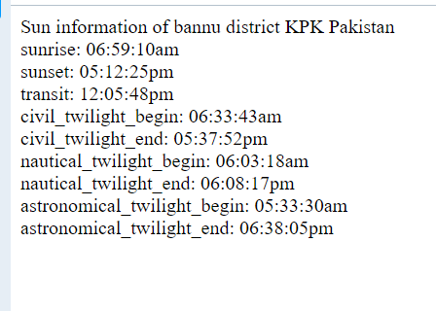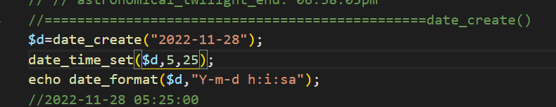

**PHP Filter filter_list() uses**

<!DOCTYPE html>

<html>

<head>

<style>

table, th, td {

  border: 1px solid black;

  border-collapse: collapse;

  color: green;

}

th, td {

  padding: 5px;

}

</style>

</head>

<body>

<table>

  <tr>

    <td>Filter Name</td>

    <td>Filter ID</td>

  </tr>

  <?php

  foreach (filter_list() as $id =>$filter) {

    echo '<tr><td>' . $filter . '</td><td>' . filter_id($filter) . '</td></tr>';

  }

  ?>

</table>

</body>

</html>

